Hypothesis testing

Claims made by company:

1. Health Drink
2. Insurance Claims
3. Marketing Claims

How True are these claims?

Eg for Electric Car: Power charge of 5 hours will cover at least 200km

Hypothesis Testing: Is is an act in statistics whereby an analyst / data scientist tests and assumption

Statistical Method to test a hypothesis by measuring and examine a random sample of the population.

1. Claims may be True: Null Hypothesis: Find the evidence that support the null hypothesis.
2. Claims may not be True: Alternate Hypothesis

Null Hypothesis: Equality between the population parameter

**Null Hypothesis: H0**

It’s the statement that the assumption is true: Test to check the claim.

If null hypothesis is rejected, the alternate hypothesis is true

**Alternate Hypothesis (H1)**

**Sample Question 1**

The annual return of a particular mutual fund is 8%. Assume that mutual fund has been in existence for 20 years. We take a random Sample of annual returns of the mutual fund for five years (sample) and calculate its mean. We then compare the (calculated) sample mean to the (claimed) population mean to verify the hypothesis.

**Null Hypothesis (H0)** The annual return of the mutual fund is 8% per annum.

**Alternative Hypothesis (H1)** The annual return of the mutual fund is NOT equal to 8% per annum.

**Sample Question 2**

Determine if the average daily return of any stock listed on XYZ stock market, around new year’s day is greater than 2%

**H0 Null:** mean <= 2%

**H1 Alternative:** mean > 2% (This is what we want to prove)

Take the sample (say of 50 stocks out of total 500) and compute the mean of the sample.

**Sample Question 3**

A monthly income investment scheme exists that promises variable monthly returns. An investor will invest in it only if they are assured of an average $180 monthly income. The investor has a sample of 300 months returns which has a mean of $190 and a standard deviation of $75. Should they invest in this scheme?

Let’s setup the problem. The investor will invest in the scheme is they are assured of the investors desired $180 average return.

**H0 Null: Mean = $180**

**H1 Alternative: Mean > $180**

Method 1: Critical value approach

Find the Z for Upper/Right Side

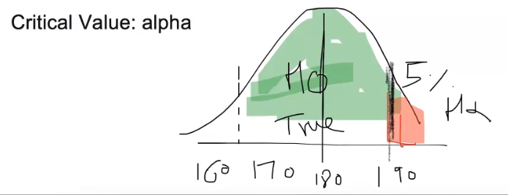

**Example question 4**

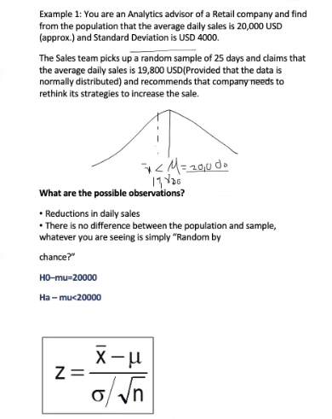

**Workings Q4**

Xbar = 19800

Mu = 20000

Std = 4000

N = 25

Zscore = (19800 – 20000) / (4000 / (sqrt25)) = -0.25

Value from Z-Table = 0.40129

